**Luz Deloria**

**Lab 5- Traceroute**

**IT-520-A**

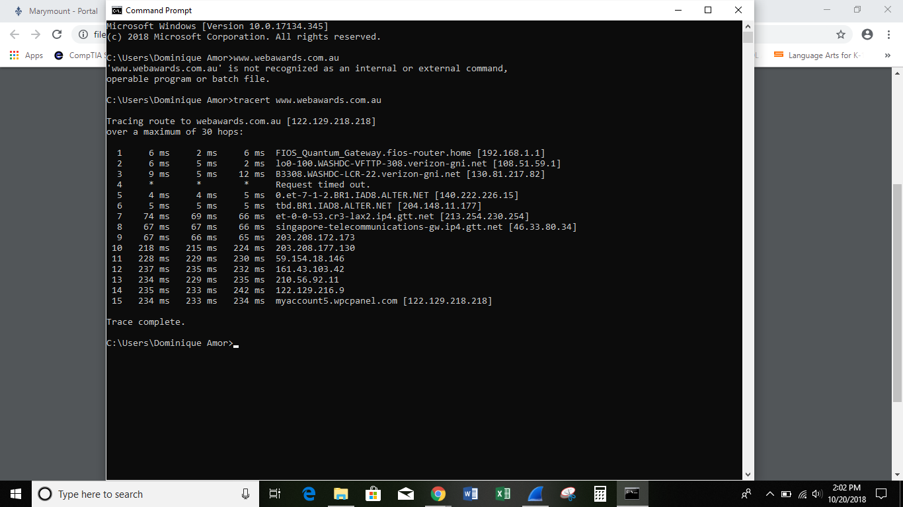

1.IP address:

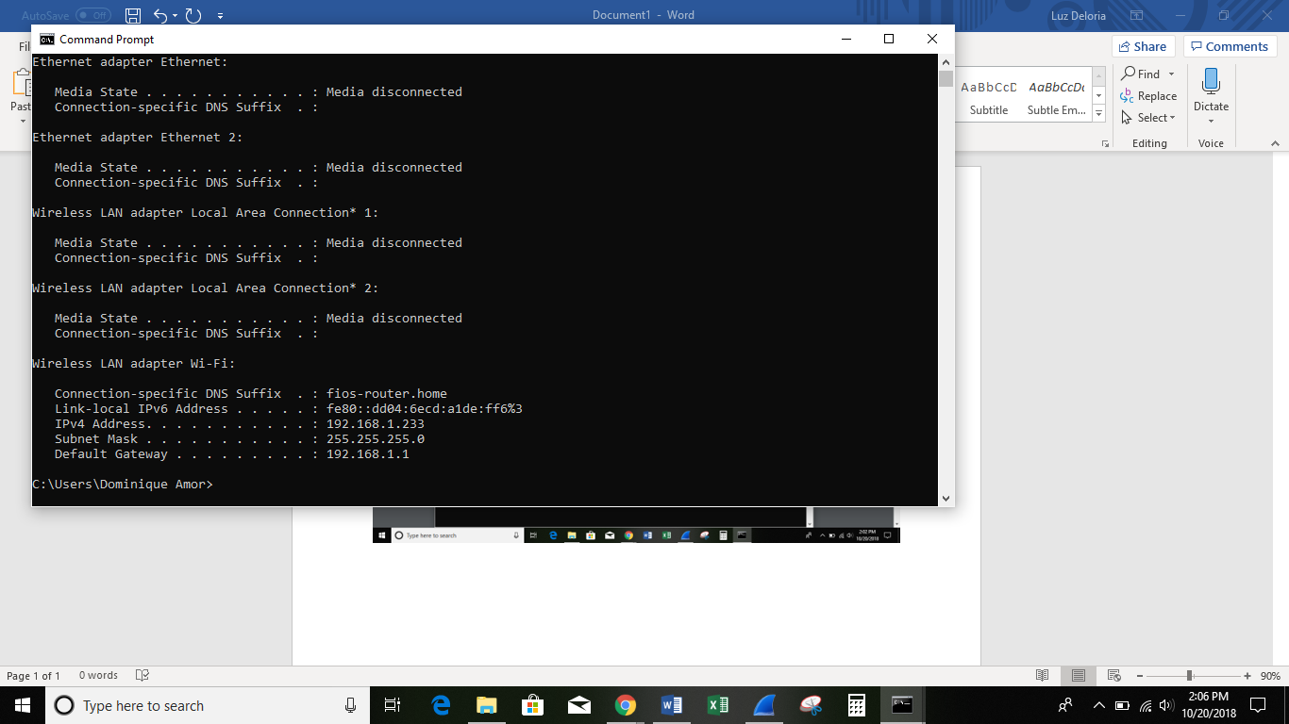

2. The IP address of the first IP from the traceroute result is: PRIVATE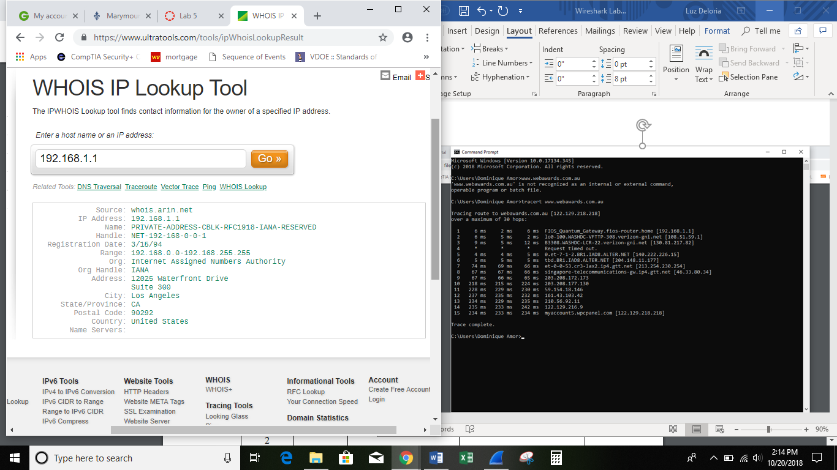

3. IP address of the second IP from the traceroute result is: PUBLIC

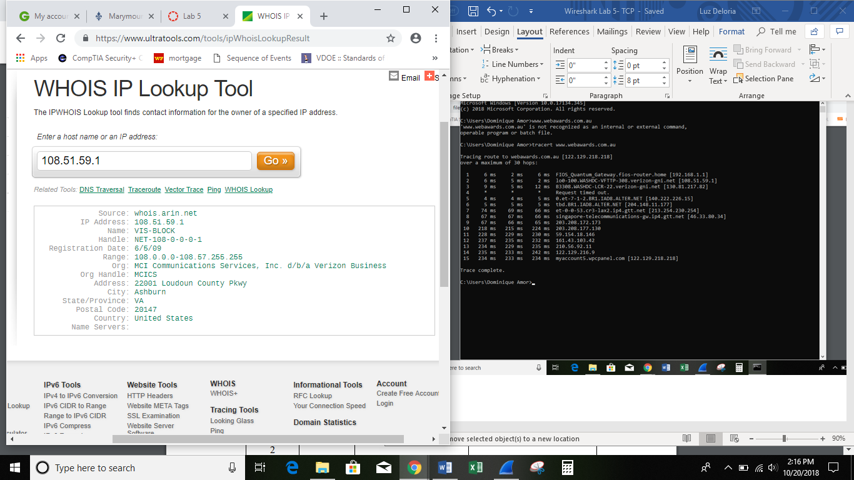

4.

|  |  |  |  |
| --- | --- | --- | --- |
| Hop Count IP address | IP address | Organization (IP Owner) | Location (US state)/Country |

|  |  |  |  |
| --- | --- | --- | --- |
| 1 | 192.168.1.1 | Internet Assigned Numbers Authority | CA/USA |
| 2 | 108.51.59.1 | MCI Communications Services, Inc. d/b/a Verizon Business | Ashburn/VA |
| 3 | 130.81.217.82 | MCI Communications Services, Inc. d/b/a Verizon Business | Ashburn/VA |

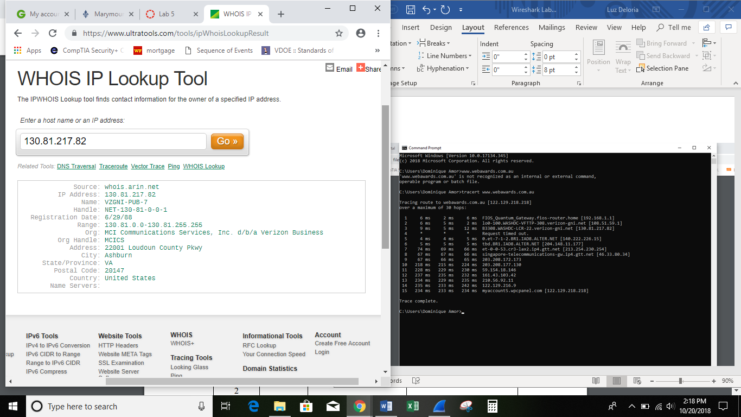

5. In your own words, explain everything you just did, and what route did your packet took from source to destination.

-

How many US states did your packet go through? How many countries if any?

* The packets go through 2 US states; CA & VA.
* It travelled to 2 more countries- Singapore, Australia

